Fits are performed via the decay function from PMID: 40767443, D = D0 / (1 + (E/a)^b)^c, with D as cone density (usually cones/mm2), D0 as cone density at the CDC (or whatever you have specified, PCD, etc), and E as eccentricity (can be in µm or whatever value).
- Initialize:
Install R Studio: https://posit.co/download/rstudio-desktop/
To run this script, you will to install these packages in RStudio:
minpack.lm, dplyr, purr, tidyr, ggplot2, zoo, openxlsx, readxl

Then open single or batch script and click Run All from top right in RStudio.
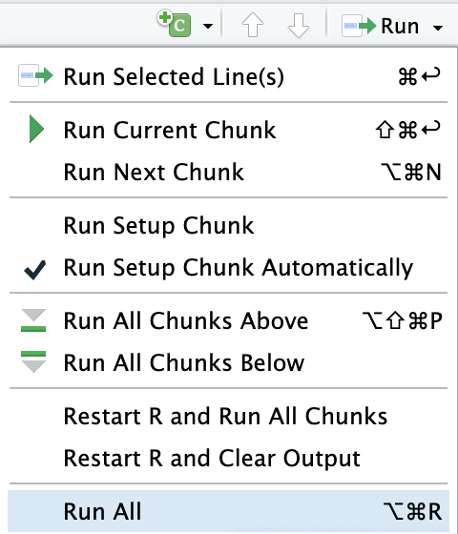
- Inputs
Input file names should be in the following format:
JC_XXXXX_OX_meridian.csv or .xlsx
JC_XXXXX: Subject ID
OX: Eye, OS or OD
Meridian: Horizontal, Temporal, Nasal, Vertical, Superior, Inferior, Radial, etc.
The batch script will prompt for an input folder. This input folder will require each file formatted the way described above. The parameter file should be in the same folder. The single script will ask you to specify which file in that folder to run the script on.
A parameter file titled “parameter_ranges.csv” will have input ranges for a, b, c, fit parameters from the sigmoid function, and is named parameter_ranges.csv . Rows are a, b, c; and columns are min/max. The third column is the seed values. These can be adjusted by the user.
Data should be formatted to start at E=0, with it’s associated density value. This location is usually either PCD or CDC.
Fitting will fail if:
- Parameter bounds too restrictive (template has ranges from PMID: 40767443)
- Parameter seed values far from optimal for that subject (template seeds set to average radial values from PMID: 40767443)
- Data not suitable for sigmoid model
- D(E) is not a function (e.g. each E only has 1 D)
  - Data needs to be monotonic, but can allow for some margin of error with D fluctuations.
- E does not start at E=0
- E has negative values

